PROJECT -2

TITLE: -

Design and Manufacturing of Voltage controller circuit using NE555P.

OBJECTIVE: -

The objective of this PCB project is to design and fabricate a voltage controller circuit using the NE555P timer IC to regulate output voltage with adjustable control. The NE555P will be configured in astable or monostable mode to generate a pulse-width modulation (PWM) signal, which will control the voltage regulator or switching element (such as a MOSFET) for efficient voltage regulation. The circuit will aim to provide precise voltage control, stability, and minimal power loss, while ensuring ease of use and integration in various applications requiring reliable voltage regulation.

INTRODUCTION: -

Voltage regulation is essential in electronic circuits to ensure a stable and consistent output despite input fluctuations. This project focuses on designing a voltage controller using the NE555P timer IC to generate Pulse Width Modulation (PWM) signals. PWM is an efficient method to control the output voltage by adjusting the duty cycle, making it ideal for powering devices like DC motors and power supplies.
The goal of this project is to design a compact, reliable PCB that uses the NE555P along with supporting components to provide stable voltage control. The resulting circuit will be cost-effective, easy to use, and suitable for various applications requiring adjustable or stable voltage.

COMPONENTS AND SPECIFICATIONS: -

- Microcontroller: NE555P, chosen for its compact size and capability to handle basic control and processing tasks.

- Power Supply: 5V regulated supply. An on-board voltage regulator is used if an unregulated power input is provided to ensure stable 5V power for the microcontroller and peripheral components.

- Capacitors and Resistors: Capacitors: 10nF to control the voltage and time interval, and 0.1uF to get clean smooth output

- Resistors:
  - 1kΩ (x2) for current-limiting purposes.
  - 1kΩ to increase the charging time of capacitor

- Flywheel Diodes: To safe path to diminished sudden surge of energy.
- Diode (2x): To create different charge and discharge path.

DESIGN PROCESS: -

1. Schematic Design-
The schematic you provided shows an electronic circuit based around a 555 timer IC (IC1).

1. Power Supply:
- The circuit is powered by a +12V supply connected to the VCC pin of the 555 timer IC (pin 8).
- Ground (GND) connections are provided at multiple points in the circuit.

2. 555 Timer IC (IC1):
- Pin 1 (GND) is connected to ground.
- Pin 2 (Trigger) is connected to a network involving resistors, capacitors, and diodes.
- Pin 3 (Output) is connected to the gate of the MOSFET (Q1).
- Pin 4 (Reset) is connected to VCC.
- Pin 5 (Control Voltage) is connected to a capacitor (C1) and a resistor (R1).
- Pin 6 (Threshold) and Pin 7 (Discharge) are connected to a network involving resistors and capacitors.
- Pin 8 (VCC) is connected to the +12V supply.

3. MOSFET (Q1):
- The MOSFET (Q1) is an N-channel MOSFET (IRFZ44NPBF).
- The gate of the MOSFET is connected to the output of the 555 timer IC (pin 3).
- The source is connected to ground.
- The drain is connected to a load (not shown) through a diode (D3).

4. Diodes:
- D1 and D2 are 1N4148B diodes connected in the network around the 555 timer IC.
- D3 is a 1N4007-T diode connected to the drain of the MOSFET.

5. Resistors and Capacitors:
- R1, R2, and R3 are resistors with values specified as MFI_4DCT26A1001F and MFI_4DCT26A1000F.
- VR1 is a variable resistor (P160KN2-0EC15B50K).
- C1 is a 10nF capacitor.
- C2 is a 0.1uF capacitor (RCESCH1047J2A2H03B).

6. Connectors:
- J1 and J2 are connectors (1700510000) for external connections.
- S1 is a switch (NGS12004).

This circuit showcases the 555 timer IC in action, controlling a MOSFET for potential switching or pulse-width modulation (PWM) applications. The use of diodes, resistors, capacitors, and a variable resistor allows for precise timing and oscillation adjustments. It's a versatile setup often used in various electronic projects.

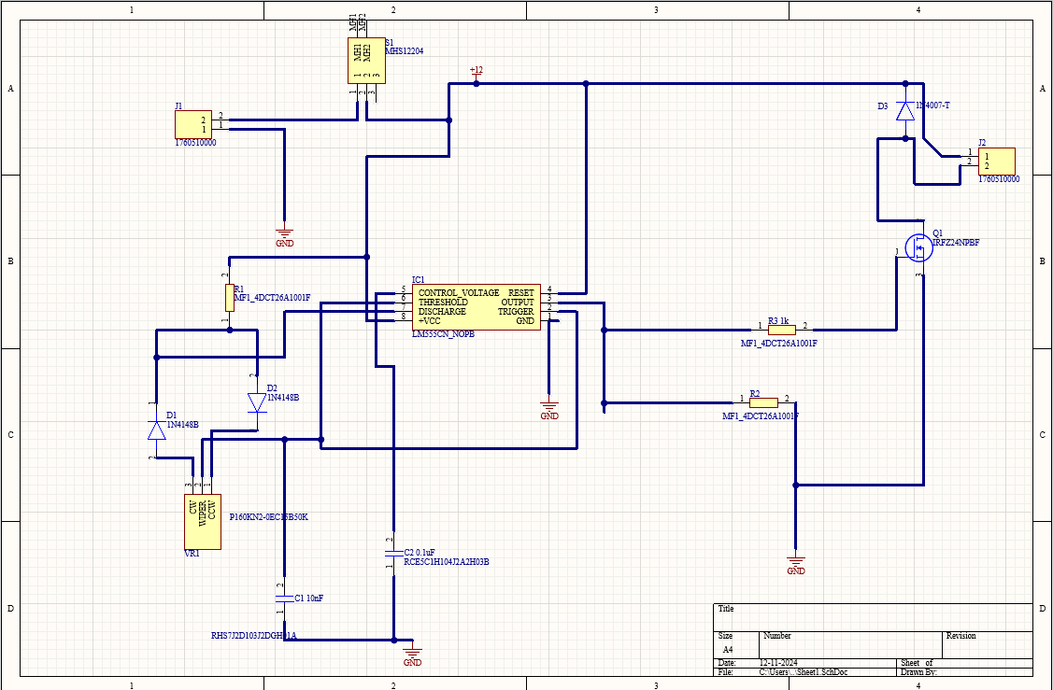

2. PCB LAYOUT:

Component Placement
- Microcontroller: Positioned centrally to minimize trace lengths to all components, with I/O pins accessible for easy debugging.
- Power Circuit: Voltage regulator (if used) and capacitors are placed near the power input for stable voltage.
- Trace Routing
- Power and Ground Traces: Wide traces are used for Vcc and ground to handle current and reduce voltage drops. A ground plane under critical areas minimizes noise and stabilizes signals.
- Signal Traces: Short, direct traces are used to prevent interference. Signal lines are routed away from high-current traces.
Clearance and Spacing
- Standard clearances are maintained throughout for safe soldering and reliable operation, particularly around high-voltage and sensitive areas.
Thermal Management
- Sufficient spacing is given around the voltage regulator for passive heat dissipation, ensuring stable operation over time.

Design for Assembly and Debugging
- Components are arranged to allow easy access to the programming header, debugging LEDs, and other critical points. The status LED is visible for quick feedback on board status.

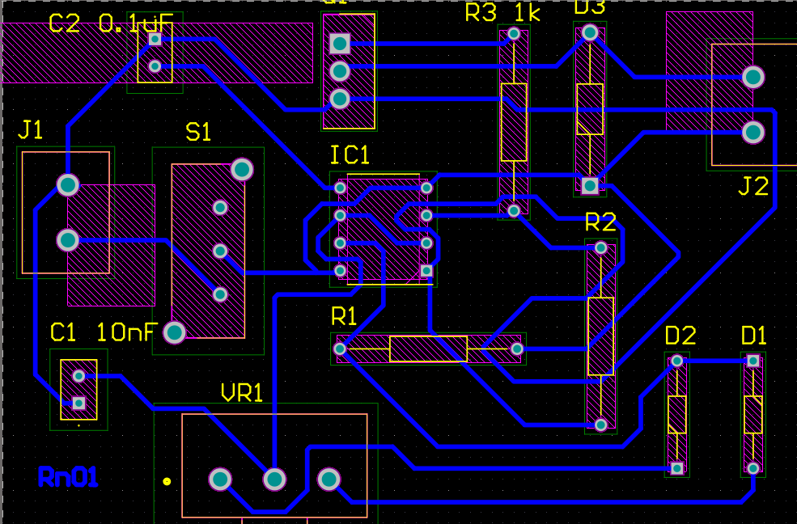

3. Assembly and Testing
Component Placement and Soldering
- After the PCB fabrication, components were carefully placed and soldered. Through-hole and surface-mount techniques were applied as required.
- Testing
- Initial testing involved verifying power supply stability and ensuring no short circuits.
- Controlling a DC motion of 12V or and LEDs of 12V by varying the potentiometer’s resistance.
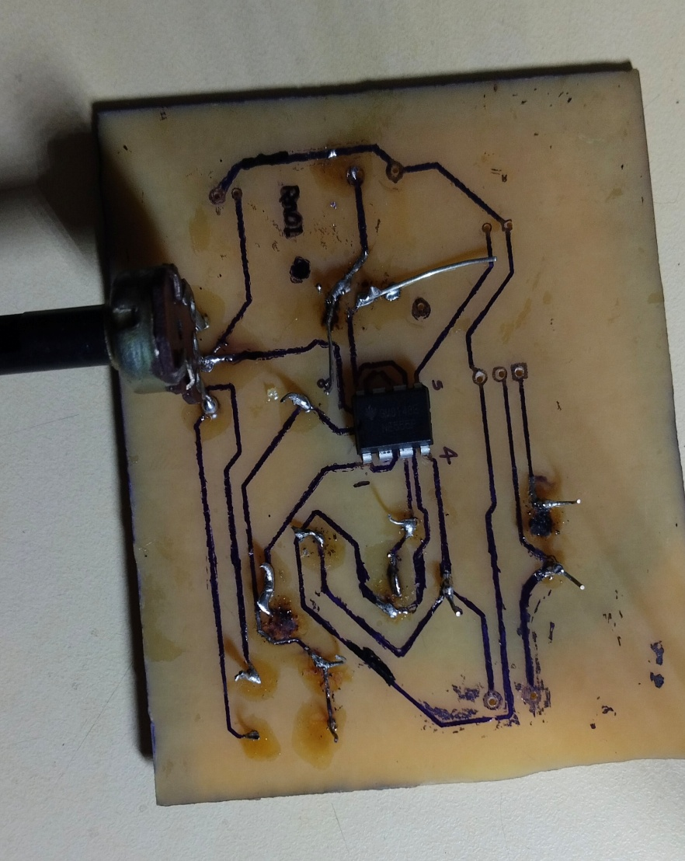
- Any issues found during testing, such as incorrect connections or component placement, were documented and rectified.

